Il Melograno galleria d’arte di Giulio Ferrieri Caputi
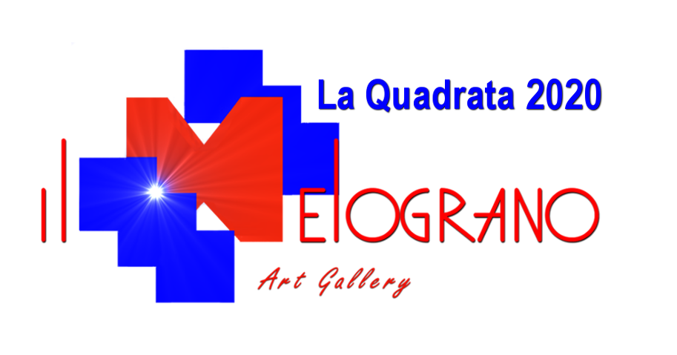
Via Marradi 62/68, Livorno
tel.0586 578592
p.iva 01666760499
info@meloarte.net

LA QUADRATA 2020
MODULO DI ISCRIZIONE

The undersigned ................................................................................. born at ........................................................ ..
the ................... resident in .................. .. .........…………....................... province ......... .. ...... ..
nation ......... .. ........................ ..
Street …………………………………………………………………………………………..……………….n°………..
email .................................................................. Tel. .................................................................................... ..
asks to participate in the contemporary art prize "La Quadrata 2020" organized by the Il Melograno gallery with online selection of the works, according to the rules published on the website www.concorsiarte.it. By accepting the regulation, the undersigned allows the publication of his own work in competition as indicated in the regulation itself, and the processing of personal data, according to the current privacy policy, for the fulfillment of tax obligations. Payment was made via
bank transfer ... .. paypal ....
THE WORK
Title……………..…………………………………………………………………………..………… year…..........
Technique…………………………….……... on ( canvas?, panel? )……………………………..cm. …………………..
Description:
write a description of the work to be published

THE ARTIST
write a description of the artist

Attach the photo of the work and an identification document to the form

